Module 5: Continuous deployments
- Explain Docker for Containerization, Basics of Docker Architecture, components, What is Containerization.
Docker for Containerization:
Docker is an open-source platform used to develop, package, ship, and run applications inside lightweight environments called containers.
It helps developers run applications consistently on different systems without dependency issues.
Features of Docker
- Lightweight and fast
- Easy deployment of applications
- Portable across systems
- Provides isolation between applications
- Efficient use of system resources

Basics of Docker Architecture:
Docker follows a client-server architecture.
Working
- The Docker Client sends commands.
- The Docker Host/Daemon processes those commands.
- Docker pulls images from Docker Registry if required.
- Containers are created and executed from Docker images.
Architecture Diagram (Simple Flow)
Docker Client → Docker Daemon → Docker Images → Docker Containers

Components of Docker Architecture:
- Docker Client
- Interface through which users interact with Docker.
- Uses commands like docker build, docker run, docker pull.
- Docker Daemon
- Background service that manages containers, images, networks, and volumes.
- Docker Images
- Read-only templates used to create containers.
- Contain application code, libraries, and dependencies.
- Docker Containers
- Running instances of Docker images.
- Lightweight and isolated environments.
- Docker Registry
- Storage location for Docker images.
- Example: Docker Hub
- Dockerfile
- Text file containing instructions to build Docker images automatically.

Containerization:
Containerization is a technology used to package an application along with its dependencies, libraries, and configuration files into a single unit called a container.
Characteristics
- Lightweight virtualization
- Runs consistently on any platform
- Shares host operating system kernel
- Faster startup compared to virtual machines
Benefits
- Portability
- Scalability
- Better resource utilization
- Isolation and security
- Easy deployment and testing

- Understanding images and containers, Explain Docker commands: build, run, images, containers.
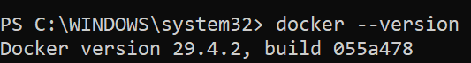
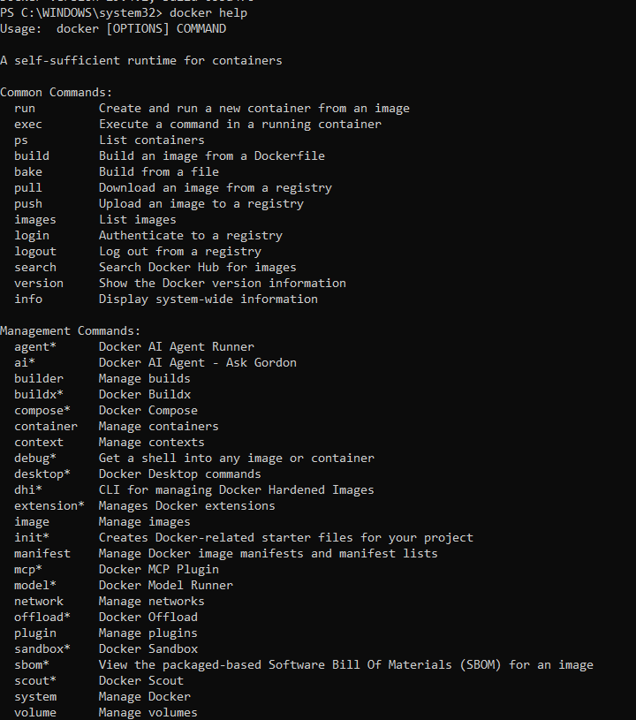
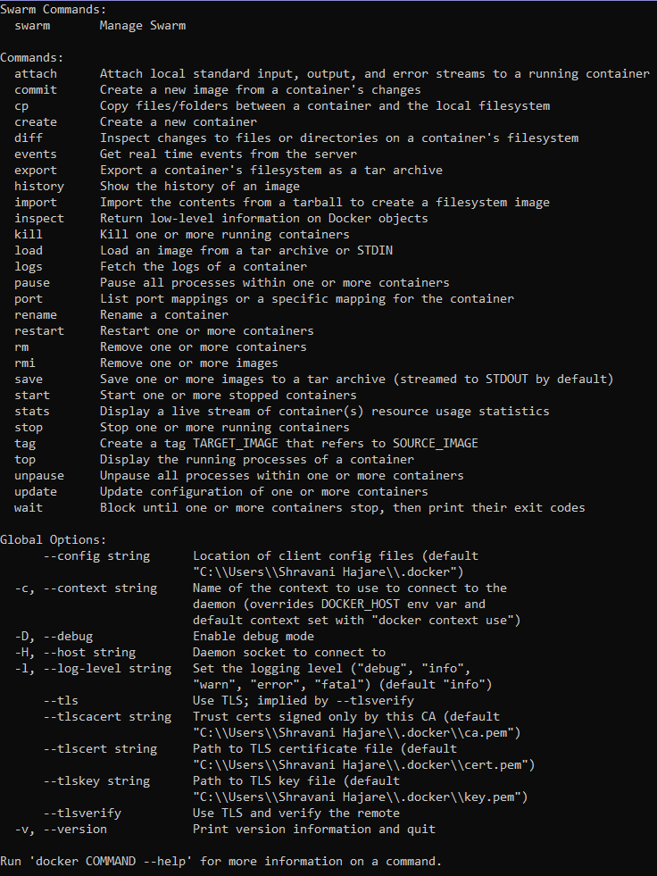

Command to create an image file : docker run hello-world
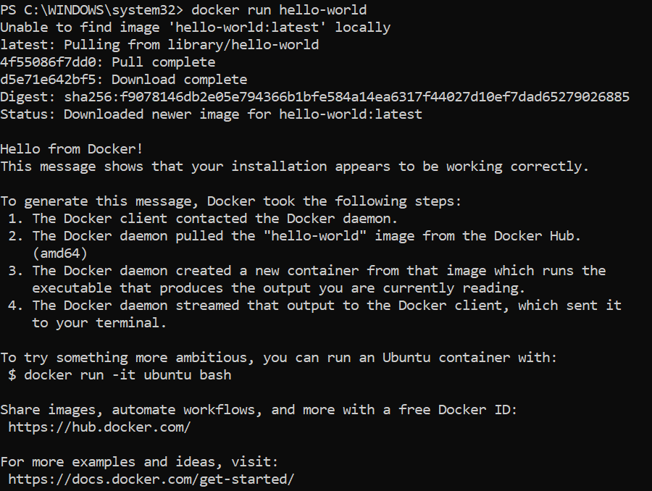
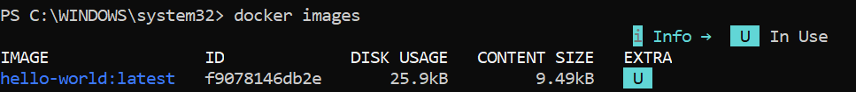
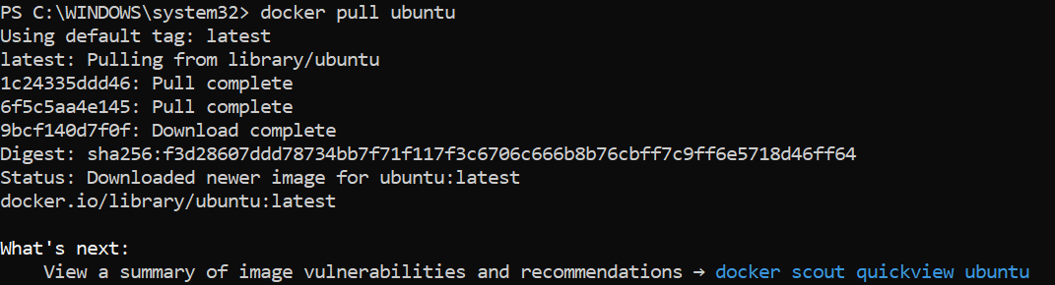

Copy the image id: f9078146db2e
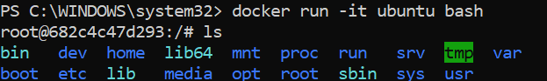
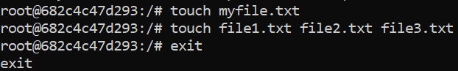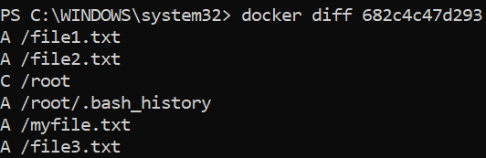
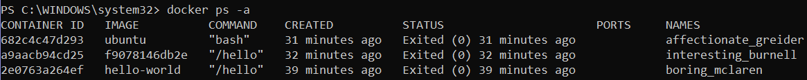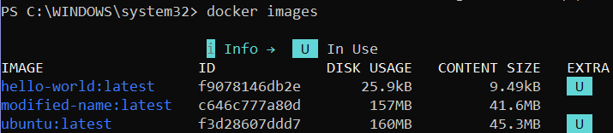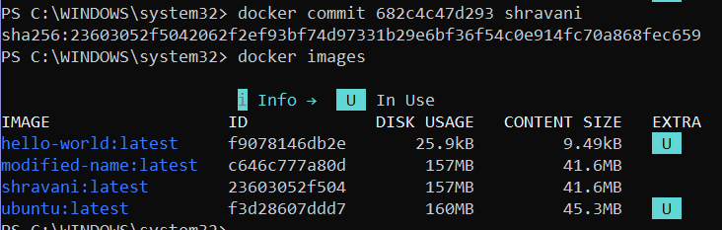

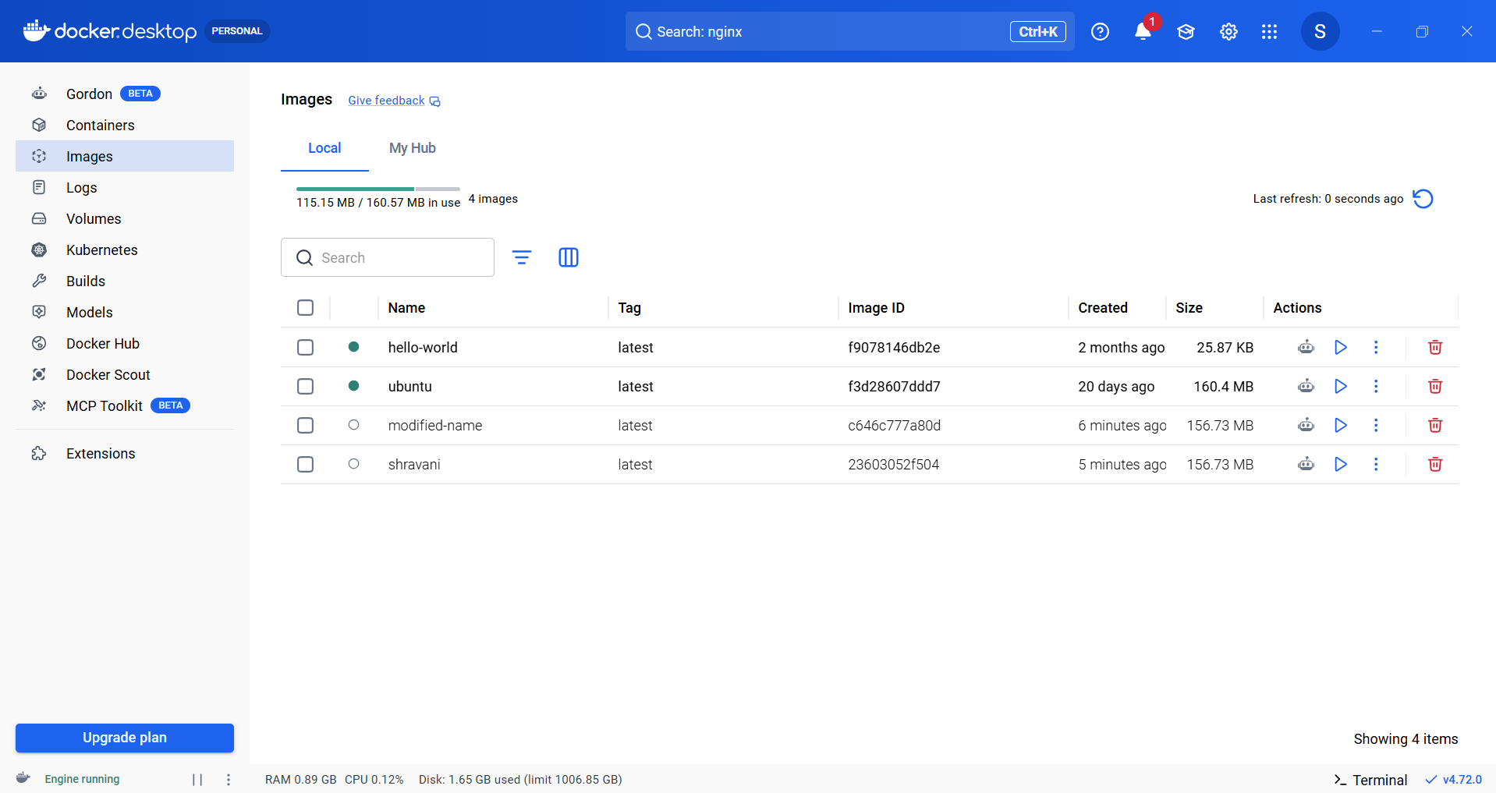
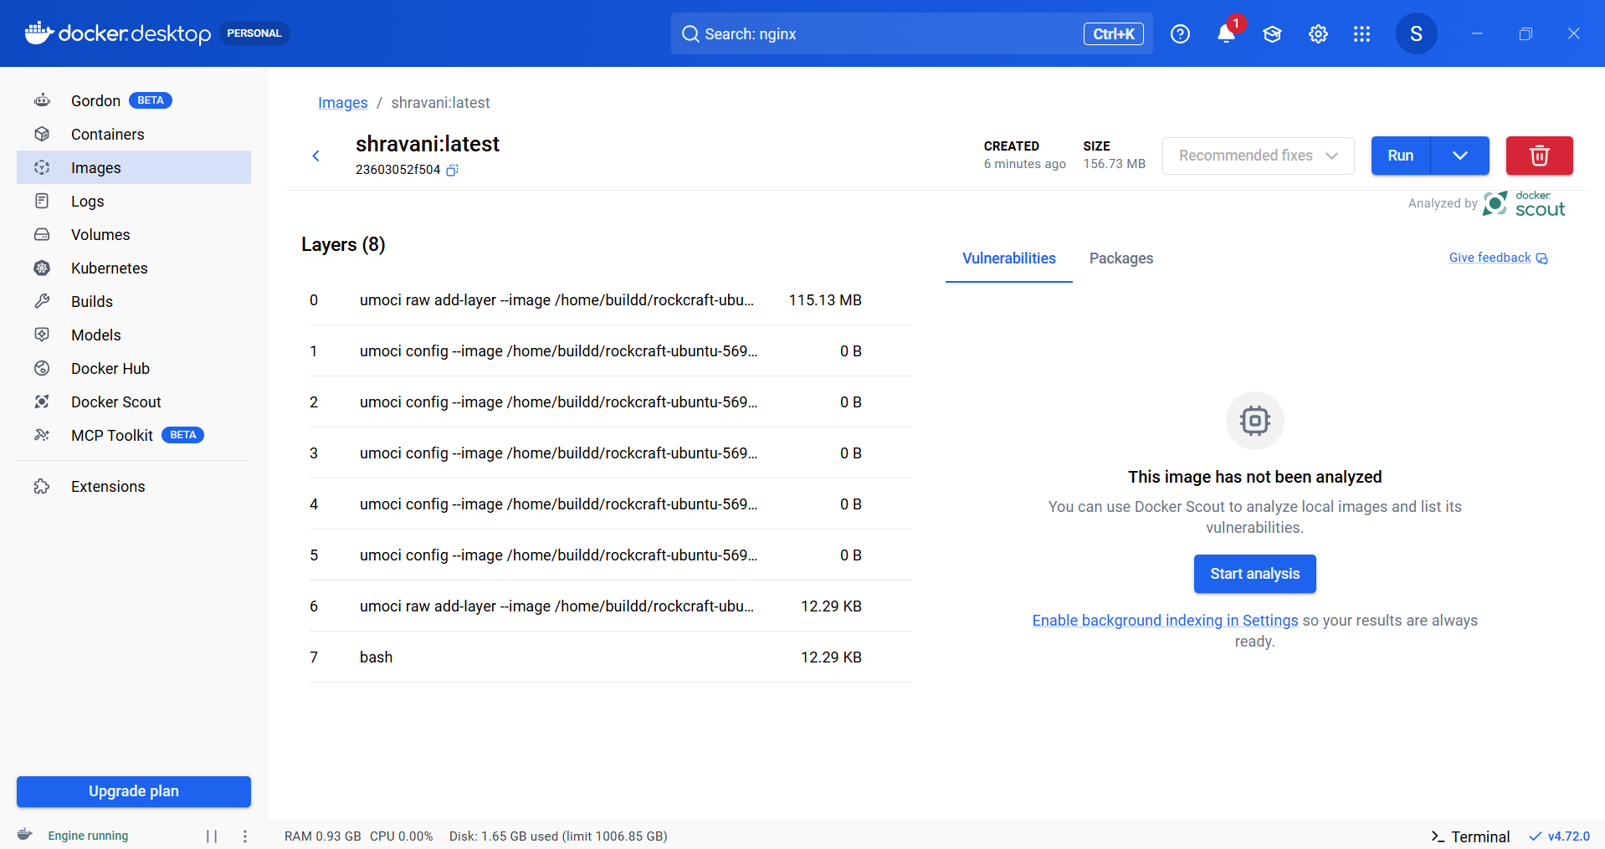

- Build, deploy and manage web/software application on Docker Engine, Docker Management (Html and python )
Using Html:
First create a folder with name App1Docker -> then create 2 filed into it -> Dockerfile and index.html
Code:
Dockerfile

FROM nginx:latest
COPY index.html /usr/share/nginx/html/index.html

index.html
<!DOCTYPE html>
<html>
<head>
<title>Service 1</title>
</head>

<body style="background-color:rgb(43,179,197);">

<h1>Service 1</h1>
<h1>Welcome to My Dockerized GitHub Html App !</h1>

<p>Hello From Service 1</p>

<img src="loading.png" alt="No image">

</body>
</html>

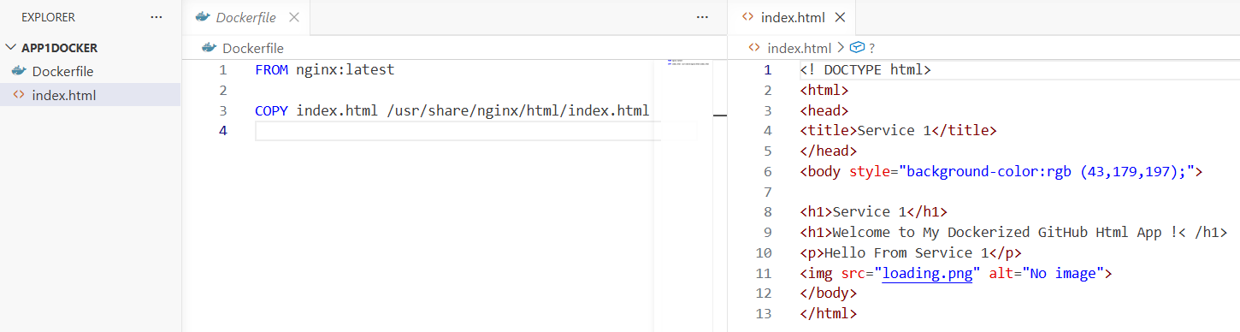
Open the folder location and right click and open in terminal -> write the following command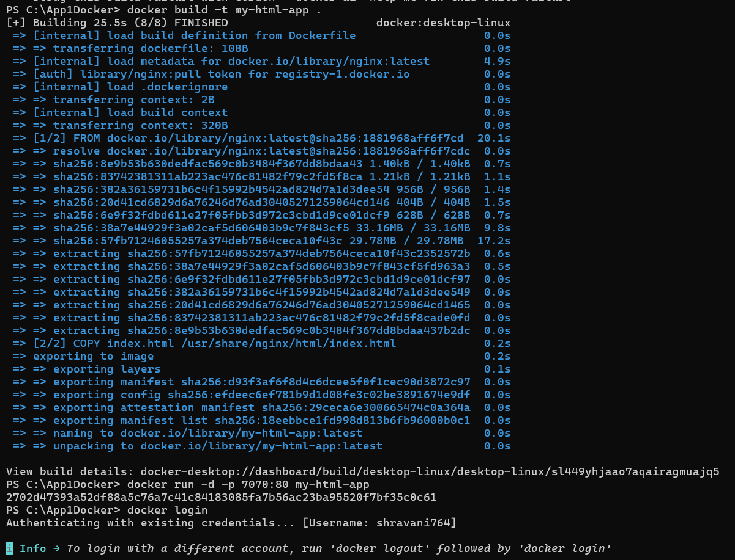
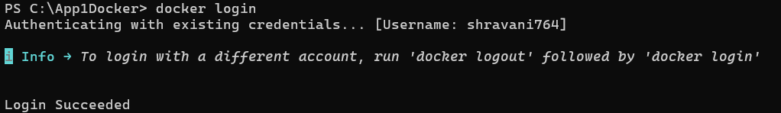
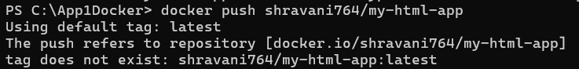
If u get an error while push command then u need run the following command
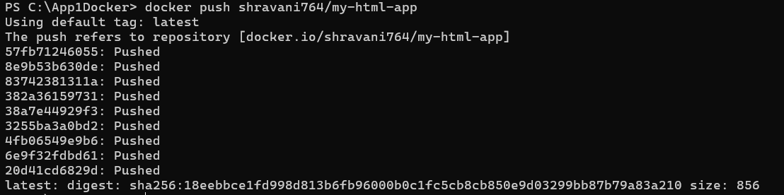
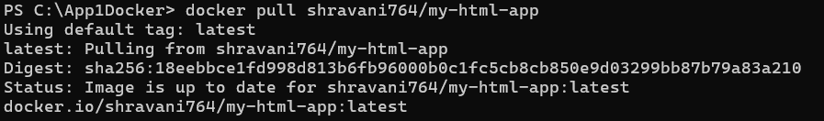

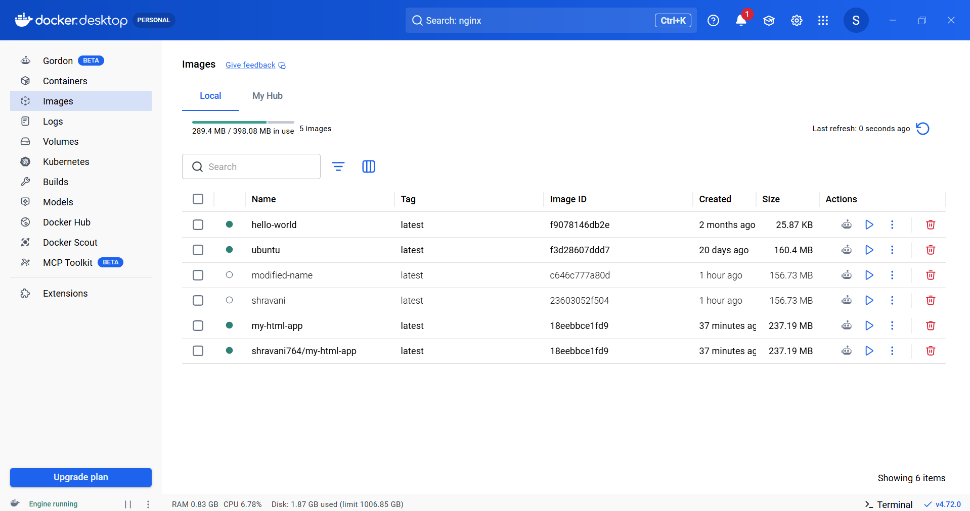
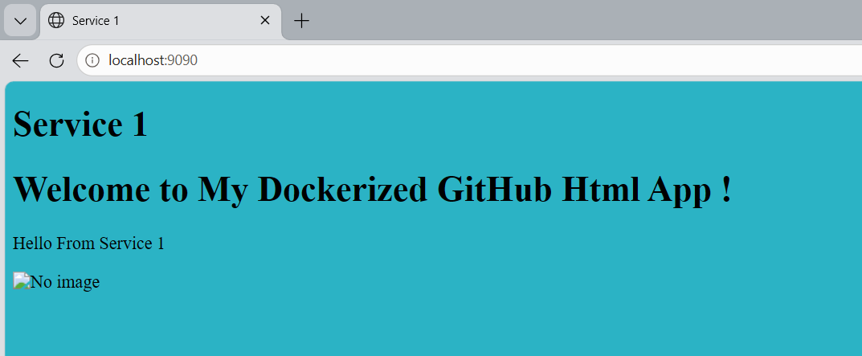

Using Python:
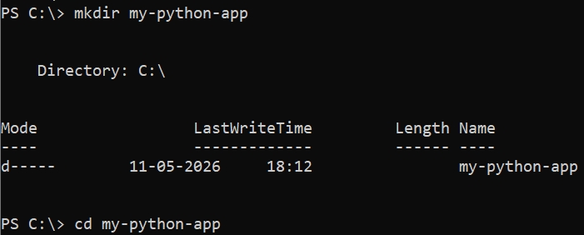
Code:
app.py
print("Hello, Docker! My Python app is running.")

Dockerfile
# Use the official Python image
FROM python:3.10

# Copy the app.py file into the container
COPY app.py /app/app.py

# Set the working directory
WORKDIR /app

# Command to run the Python script
CMD ["python", "app.py"]

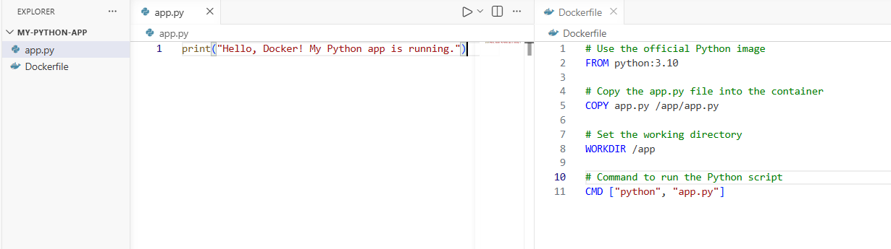
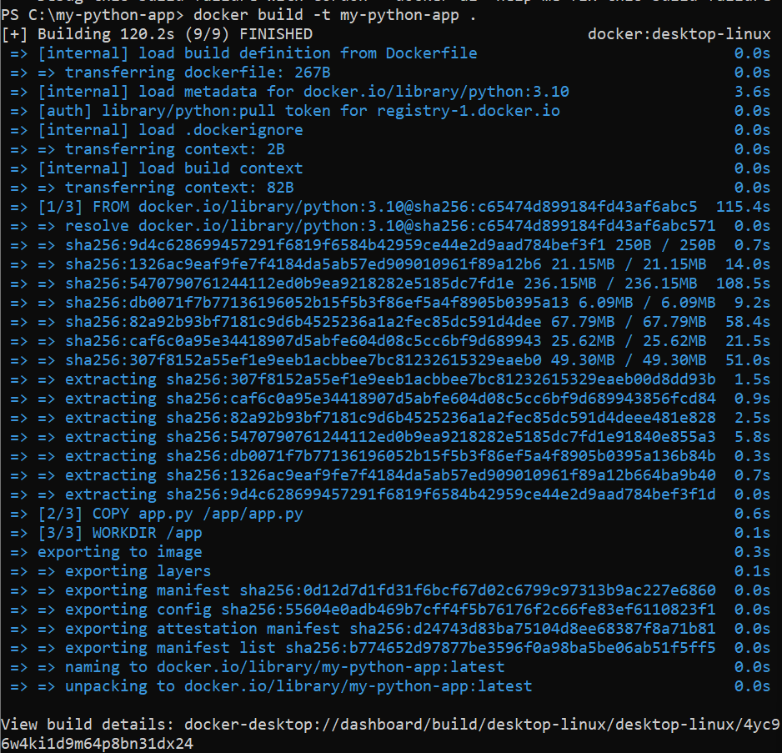

Modify and run the python script (app.py)
Open app.py and edit it
import time
# Print a message every 2 seconds
while True:
print("Hello, Docker! My Python app is running and updating...")
time.sleep(2)

Now Rebuild and run in docker
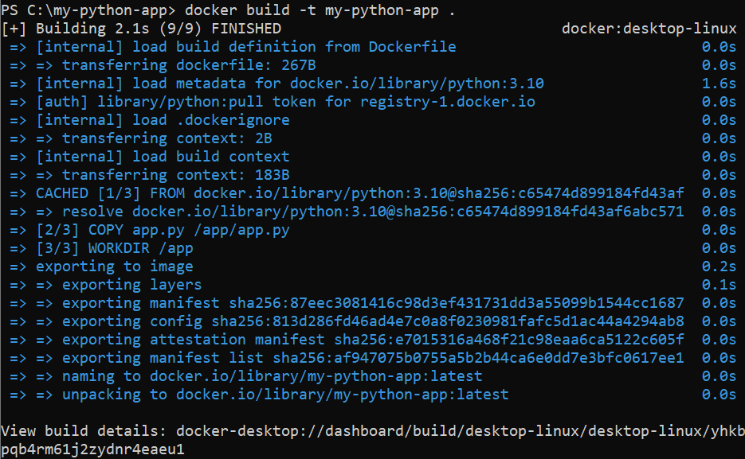
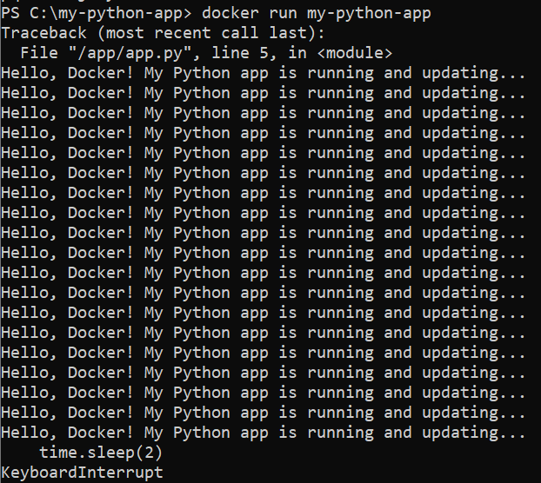
Note: Press ctrl + c to stop the script.

